MEMO

**FROM:** Edward Ma, W0057568, 701

**TO:** Bill Cunningham

**DATE:** 10-12-2016

**SUBJECT**: DBAS 1001 Assignment #3

* **Existing System Details:**From assg3.docx, it gives a set data type and information from “The Soapscum Windows Scenario”, The Lame Events Scenario”, “The Cindy’s Parties Scenario”.
* **Statement of Requirements**:   
  I will supply an Entity Relationship Diagram (ERD) using Microsoft Visio and Data Dictionary that together will provide all of the information that is necessary for creating a database that is capable of storing all the data needed for each of the three scenarios.
* **Analysis:**

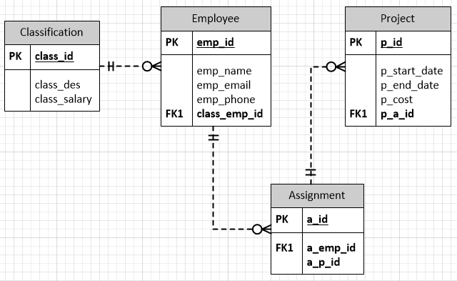***The Soapscum Windows Scenario  
ERD:***

***Data Dictionary:***

|  |  |  |  |  |
| --- | --- | --- | --- | --- |
| *OBJECT NAME* | *OBJECT TYPE* | *DATATYPE* | *METHODS* | *NOTES* |
| Classification | Table | N/A |  | The scenario dictates a need to track job classification. Classification must be uniquely identified |
| class_id | Field | INTEGER | PK | Required to identify each job classifications |
| class_des | Field | VARCHAR(30) |  | Description of each job classifications |
| class_salary | Field | CURRENCY |  | Salary determine per job classification |
| Employee | Table | N/A |  | The scenario dictates a need to track employee. employee must be uniquely identified |
| emp_id | Field | INTEGER | PK | Required to uniquely identify each employee |
| emp_name | Field | VARCHAR(30) |  | Employees’ name |
| emp_email | Field | VARCHAR(20) |  | Employees’ email |
| emp_phone | Field | VARCHAR(10) |  | Employees’ phone |
| class_emp_id | Field | INTEGER | FK | A field is required to uniquely identify which classification (class_id) is connected to a particular employee(emp_id). INTEGER datatype to match classification(class_id). |
| Assignment | Table | N/A |  | The scenario dictates a need to track each assignment. Each assignment must be uniquely identified |
| a_id | Field | INTEGER | PK | Required to uniquely identify each assignment |
| a_emp_id | Field | INTEGER | FK | Each assignment (a_id) is connected to a particular employee (emp_id) |
| a_p_id | Field | INTEGER | FK | Each assignment (a_id) is connected to a particular project (p_id) |
| Project | Table | N/A |  | The scenario dictates a need to track each Project. Each Project must be uniquely identified |
| p_id | Field | INTEGER | PK | Required to uniquely identify each project |
| p_start_date | Field | DATE |  | Project start date |
| p_end_date | Field | DATE |  | Project end date |
| p_cost | Field | CURRENCY |  | Cost of project |
| p_a_id | Field | INTEGER | FK | A field is required to uniquely identify which project (p_id) is connected to which assignment (a_id) |

***The Lame Events Scenario***

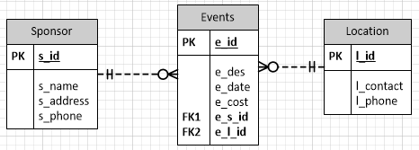***ERD:***

***Data Dictionary:***

|  |  |  |  |  |  |
| --- | --- | --- | --- | --- | --- |
| *OBJECT NAME* | *OBJECT TYPE* | | *DATATYPE* | *METHODS* | *NOTES* |
| Sponsor | | Table | *N/A* |  | The scenario dictates a need to track each Sponsor. Each Sponsor must be uniquely identified |
| s_id | | Field | INTEGER | PK | Required to uniquely identify each sponsor |
| s_name | | Field | VARCHAR(30) |  | Name of sponsor |
| s_address | | Field | VARCHAR(30) |  | Address of sponsor |
| s_phone | | field | VARCHAR(10) |  | Phone number of sponsor |
| Events | | Table | N/A |  | The scenario dictates a need to track each Events. Each Events must be uniquely identified |
| e_id | | Field | Integer |  | Required to uniquely identify each events |
| e_des | | Field | VARCHAR(10) |  | Description of each events |
| e_date | | Field | DATETIME |  | Date of each events |
| e_cost | | Field | CURRENCY |  | Cost of each events |
| e_s_id | | Field | INTEGER | FK | Each events (e_id) is connected to a particular sponsor (s_id) |
| e_l_id | | Field | INTEGER | FK | Each events (e_id) is held at a one location (l_id) |
| Location | | Table | N/A |  | The scenario dictates a need to track each Location. Each Location must be uniquely identified |
| l_contact | | Field | VARCHAR(30) |  | Location contact person name |
| l_phone | | field | VARCHAR(10) |  | Location contact person phone number |

***The Cindy’s Parties Scenario***

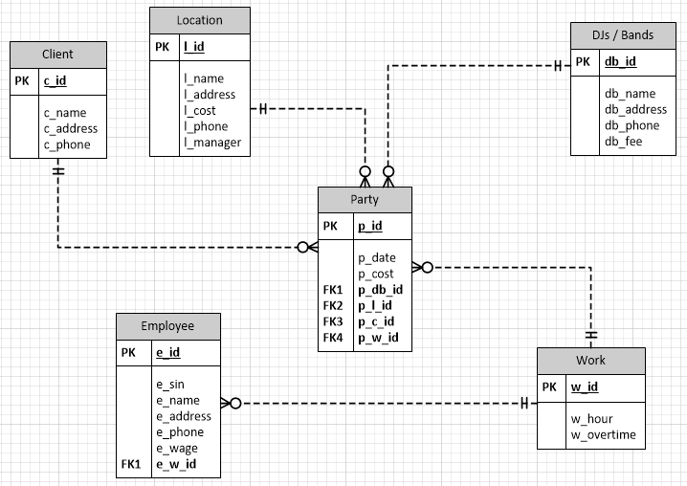***ERD:***

***Data Dictionary:***

|  |  |  |  |  |  |
| --- | --- | --- | --- | --- | --- |
| *OBJECT NAME* | *OBJECT TYPE* | | *DATATYPE* | *METHODS* | *NOTES* |
| Client | | Table | *N/A* |  | The scenario dictates a need to track each Client. Each Client must be uniquely identified |
| c_id | | Field | INTEGER | PK | Required to uniquely identify each Client |
| s_name | | Field | VARCHAR(30) |  | Name of Client |
| s_address | | Field | VARCHAR(30) |  | Address of Client |
| s_phone | | field | VARCHAR(10) |  | Phone number of Client |
| Location | | Table | N/A |  | The scenario dictates a need to track each Location. Each Location must be uniquely identified |
| l_id | | Field | INTEGER | PK | Required to uniquely identify each Location |
| l_name | | Field | VARCHAR(30) |  | Name of each Location |
| l_address | | Field | VARCHAR(30) |  | Address of each location |
| l_cost | | Field | CURRENCY |  | Cost of each Location |
| l_phone | | Field | VARCHAR(10) |  | Phone for each Location |
| l_manager | | Field | VARCHAR(30) |  | Name of the location manager |
| DJs / Bands | | Table | N/A |  | The scenario dictates a need to track each DJs or Bands. Each DJs or Bands must be uniquely identified |
| db_id | | Field | INTEGER | PK | Required to uniquely identify each DJs or Bands |
| db_name | | field | VARCHAR(30) |  | Name of each DJs or Bands |
| db_address | | Field | VARCHAR(30) |  | Address of each DJs or Bands |
| db_phone | | Field | VARCHAR(10) |  | Phone for each DJs or Bands |
| db_fee | | Field | CURRENCY |  | The fee each DJs or Bands will charge |
| Party | | Table | N/A |  | The scenario dictated the need to track each party. Each party must be uniquely identify |
| p_id | | Field | INTEGER |  | Required to uniquely identify each party |
| p_cost | | Field | CURRENCY |  | Cost of each party |
| p_db_id | | Field | INTEGER | FK | Each party (p_id) will have one DJ or band playing (db_id) |
| p_l_id | | Field | INTEGER | FK | Each party (p_id) will be held in one location (l_id) |
| p_c_id | | Field | INTEGER | FK | Each party (p_id) will have one client (c_id) |
| p_w_id | | Field | INTEGER | FK | Each party (p_id) will have employee workikng (w_id) |
| Work | | Table | N/A |  | The scenario requires a way to calculate the work hour and overtime. Each work must be uniquely identify |
| w_id | | Field | INTEGER |  | Required to uniquely identify each work. |
| w_hour | | Field | DATETIME |  | Each work will have a set of working hours |
| w_overtime | | Field | DATETIME |  | If employee work over 48 hours (by NS labour standards), they must be pay overtime at 1.5x per hour of over time |
| w_p_id | | Field | INTEGER |  | Required to track work (w_id) for each party (p_id) |
| w_e_id | | Field | INTEGER |  | Required to track employee (e_id) that worked (w_id) |
| Employee | | Table | N/A |  | The scenario requires to track each employee. Each employee will be uniquely identify |
| e_id | | Field | INTEGER |  | Required to uniquely identify each employee |
| e_sin | | Field | VARCHAR(9) |  | Social Insurance Number of each employee |
| e_name | | Field | VARCHAR(30) |  | Name of each employee |
| e_address | | Field | VARCHAR(30) |  | Address of each employee |
| e_phone | | Field | VARCHAR(10) |  | Phone number of each employee |
| e_wage | | Field | CURRENCY |  | The hourly wage of each employee |
| e_w_id | | Field | INTEGER | FK | Each employee (e_id) will have to work (w_id) |

* **Recommendation**My recommendation is to follow the ERD along with Data Dictionary for each scenarios above to be develop, which will satisfy the Statement of Requirement.